 NAME:Aryaman Mishra

**REG. NUMBER: 19BCE1027**

**EXPERIMENT NO.3**

**DATE: 4-2-22**

* **TITLE OF THE EXPERIMENT**

**Emotional Intelligence**

* **AIM:**

To compare data from individual and group results from Emotional Intelligence Quiz.

* **MATERIALS REQUIRED:**

Google forms,Internet Connection,MS Excel

* **DESCRIPTION OF TEST:**

Emotional intelligence (EI) refers to the ability to perceive, control, and evaluate emotions. Some researchers suggest that emotional intelligence can be learned and strengthened, while others claim it's an inborn characteristic.

The ability to express and control [emotions](https://www.verywellmind.com/what-are-emotions-2795178) is essential, but so is the ability to understand, interpret, and respond to the emotions of others. Imagine a world in which you could not understand when a friend was feeling sad or when a co-worker was angry. Psychologists refer to this ability as emotional intelligence, and some experts even suggest that it can be [more important than IQ](https://www.verywellmind.com/iq-or-eq-which-one-is-more-important-2795287) in your overall success in life.

A number of different assessments have emerged to measure levels of emotional intelligence. Such tests generally fall into one of two types: self-report tests and ability tests.

[Self-report tests](https://www.verywellmind.com/what-is-a-self-report-inventory-2795587) are the most common because they are the easiest to administer and score. On such tests, respondents respond to questions or statements by rating their own behaviors. For example, on a statement such as "I often feel that I understand how others are feeling," a test-taker might describe the statement as disagree, somewhat disagree, agree, or strongly agree.

Ability tests, on the other hand, involve having people respond to situations and then assessing their skills. Such tests often require people to demonstrate their abilities, which are then rated by a third party.

If you are taking an emotional intelligence test administered by a mental health professional, here are two measures that might be used:

[Mayer-Salovey-Caruso Emotional Intelligence Test (MSCEIT)](https://www.mhs.com/MHS-Talent?prodname=msceit) is an ability-based test that measures the four branches of Mayer and Salovey's EI model. Test-takers perform tasks designed to assess their ability to perceive, identify, understand, and manage emotions.

[Emotional and Social Competence Inventory (ESCI)](http://www.eiconsortium.org/measures/eci_360.html) is based on an older instrument known as the Self-Assessment Questionnaire and involves having people who know the individual offer ratings of that person’s abilities in several different emotional competencies. The test is designed to evaluate the social and emotional abilities that help distinguish people as strong leaders.

There are also plenty of more informal online resources, many of them free, to investigate your emotional intelligence.

Researchers suggest that there are four different levels of emotional intelligence including emotional perception, the ability to reason using emotions, the ability to understand emotions, and the ability to manage emotions.1

﻿

Perceiving emotions: The first step in understanding emotions is to perceive them accurately. In many cases, this might involve understanding nonverbal signals such as body language and facial expressions.

Reasoning with emotions: The next step involves using emotions to promote thinking and cognitive activity. Emotions help prioritize what we pay attention and react to; we respond emotionally to things that garner our attention.

Understanding emotions: The emotions that we perceive can carry a wide variety of meanings. If someone is expressing angry emotions, the observer must interpret the cause of the person's anger and what it could mean. For example, if your boss is acting angry, it might mean that they are dissatisfied with your work, or it could be because they got a speeding ticket on their way to work that morning or that they've been fighting with their partner.

Managing emotions: The ability to manage emotions effectively is a crucial part of emotional intelligence and the highest level. Regulating emotions and responding appropriately as well as responding to the emotions of others are all important aspects of emotional management.

The four branches of this model are arranged by complexity with the more basic processes at the lower levels and the more advanced processes at the higher levels. For example, the lowest levels involve perceiving and expressing emotion, while higher levels require greater conscious involvement and involve regulating emotions.

* **PROCEDURE**

Our emotional intelligence quiz describes situations that we all experience in our lives (like being given difficult feedback). Be as honest as possible when answering the questions as that will provide you with the most accurate assessment of your level of [**Emotional Intelligence**](https://www.ihhp.com/meaning-of-emotional-intelligence/). Once you have taken the quiz, you will receive your results as well as recommendations on how you can manage your emotions and connect more skillfully with others.

* **TABLE 1:**

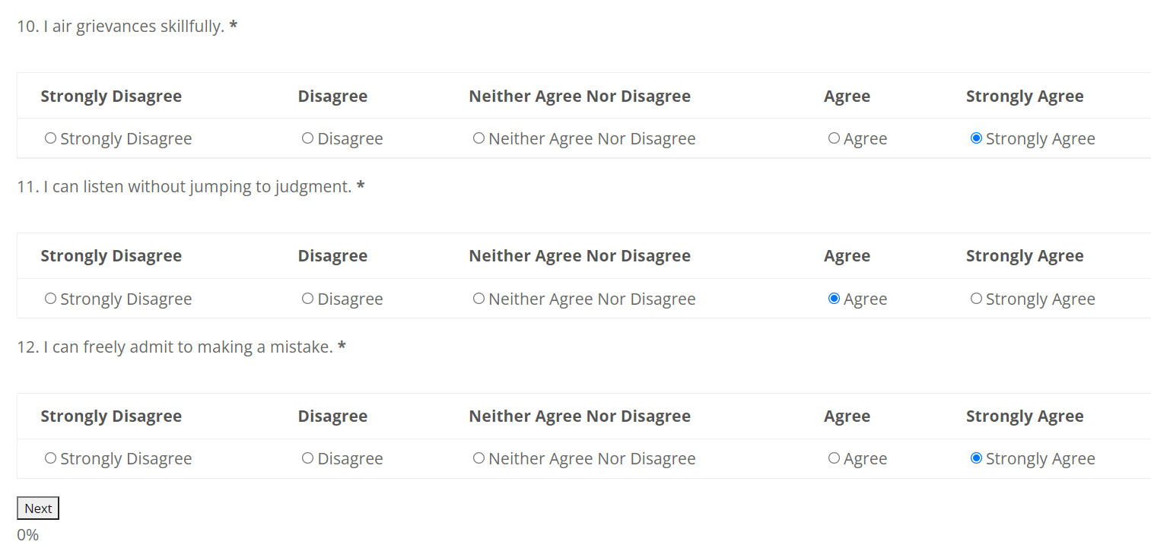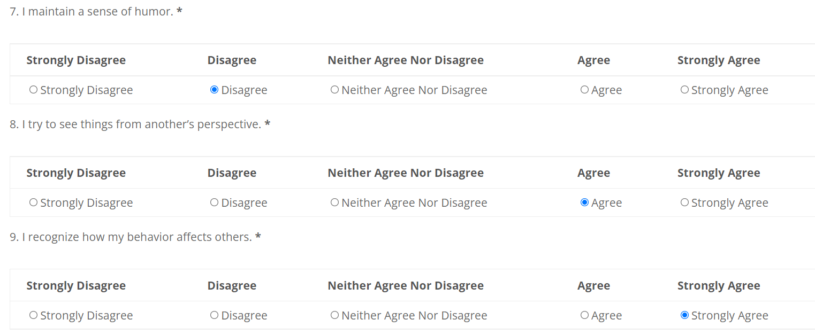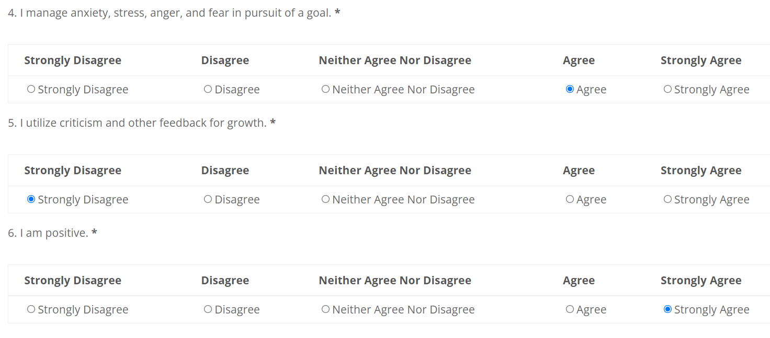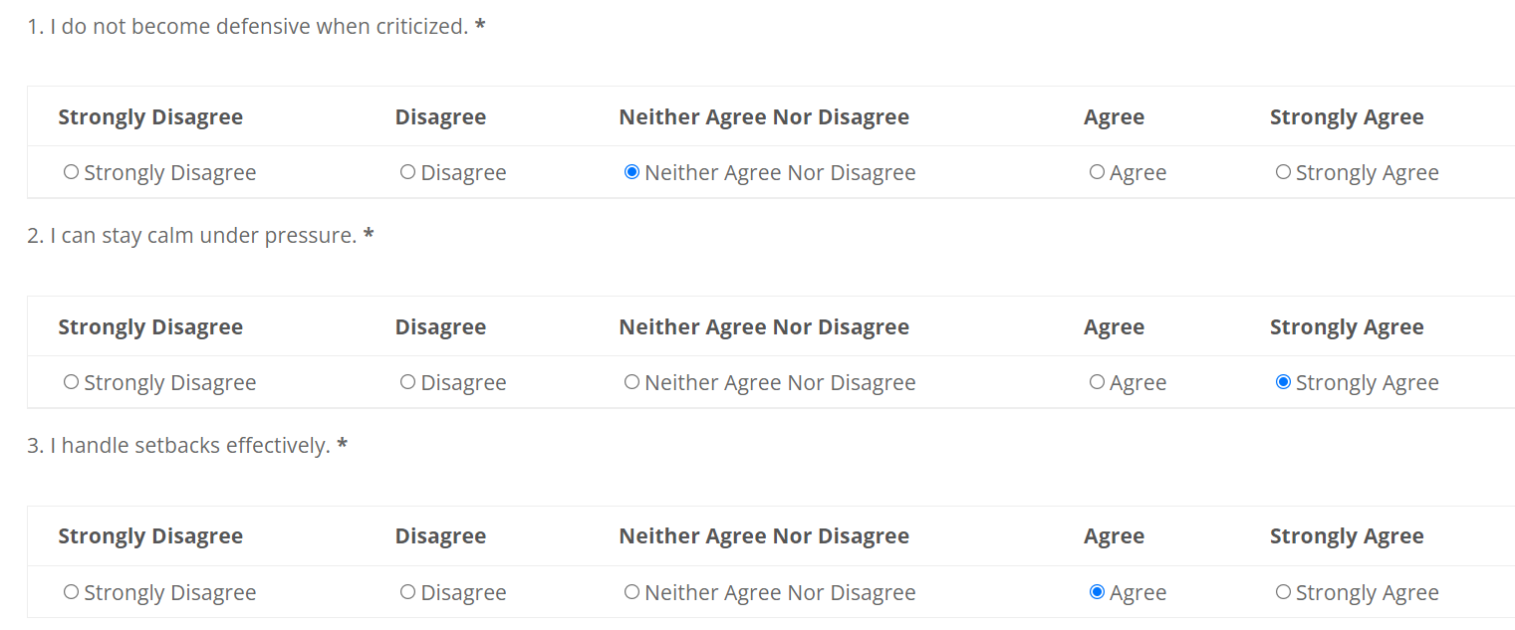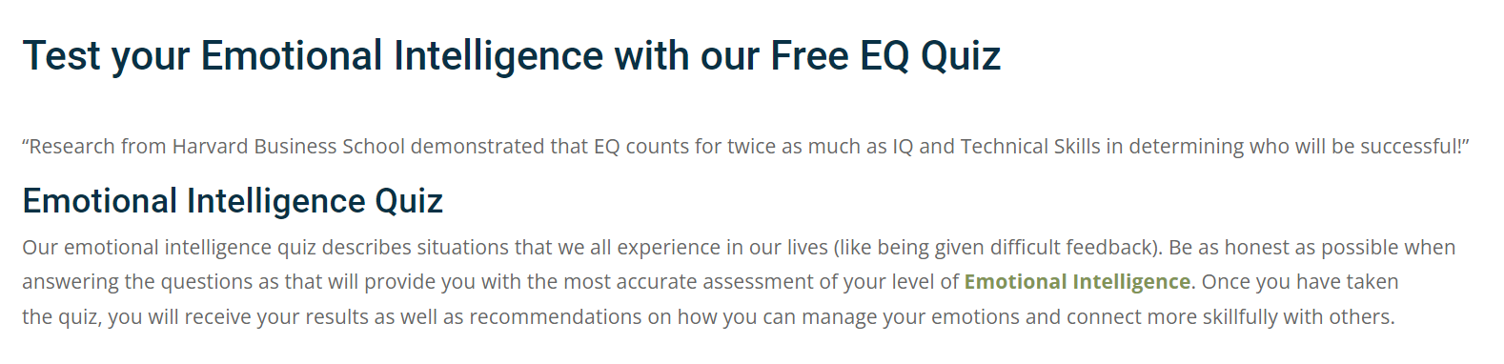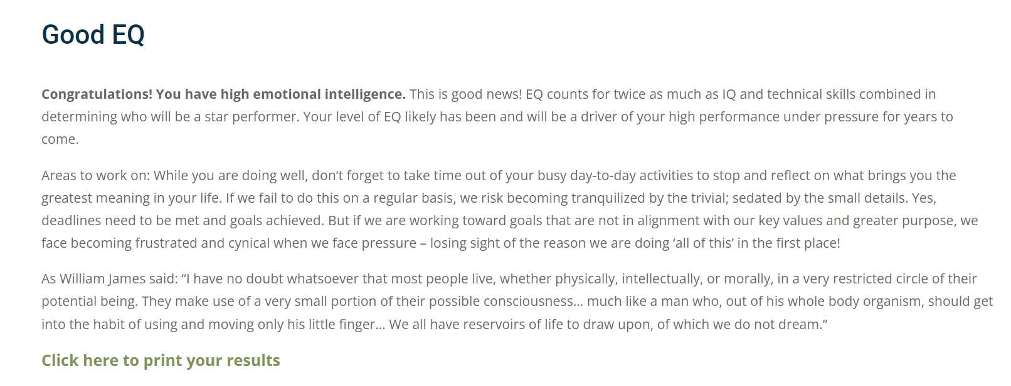

**INDIVIDUAL DISCUSSION**

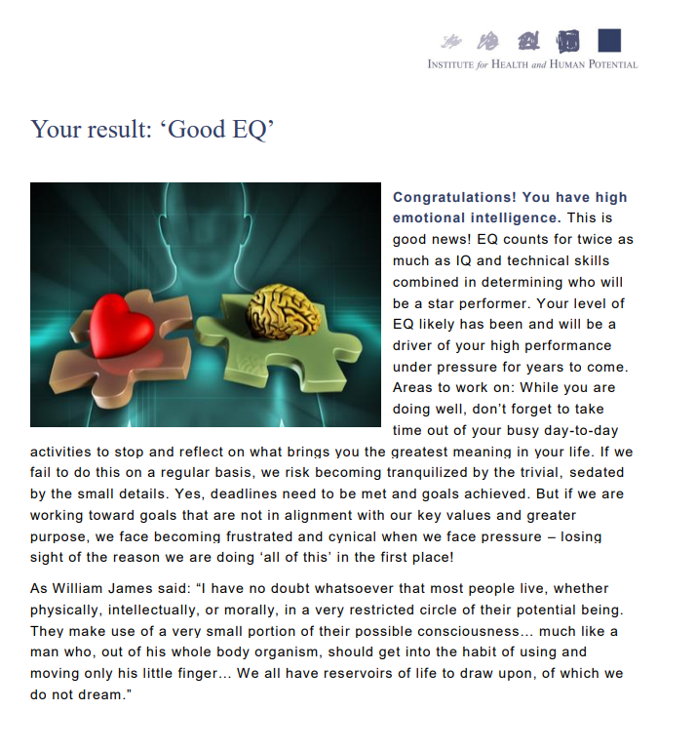

* **TABLE 2:**

|  |  |  |  |  |  |
| --- | --- | --- | --- | --- | --- |
| Timestamp | Name? | Gender? | Year of Joining? | Branch? | Result Of the test? |
| 2-4-2022 13:08:45 | Var | Female | 2019 | ECE | Good EQ |
| 2-4-2022 13:08:49 | Iyer Ashwin Raja | Male | 2019 | ECM | Average |
| 2-4-2022 13:08:53 | Krethik B | Male | 2019 | ECM | Average EQ |
| 2-4-2022 13:09:12 | Aryaman Mishra | Male | 2019 | SCOPE | Good EQ |
| 2-4-2022 13:09:23 | W | Prefer not to say | 2020 | SCOPE | Good EQ |
| 2-4-2022 13:09:29 | Deva R | Male | 2019 | SELECT | Excellent EQ |
| 2-4-2022 13:09:35 | AC | Male | 2020 | CSE with AI and Robotics | Average EQ |
| 2-4-2022 13:09:43 | SSK | Female | 2019 | - | Poor EQ |
| 2-4-2022 13:09:43 | s | Male | 2019 | eee | Good EQ |
| 2-4-2022 13:09:50 | Swayon Bhunia | Male | 2019 | CSE Core | Average EQ |
| 2-4-2022 13:10:08 | Harish Raghav.M | Male | 2019 | Mechanical Engineering | Good EQ |
| 2-4-2022 13:10:13 | M V Mythreyen | Male | 2019 | Mechanical Engineering | Good EQ |
| 2-4-2022 13:10:14 | Muhilan S | Male | 2019 | Mechanical | Good IQ |
| 2-4-2022 13:10:20 | A B | Female | 2019 | ECE | GOOD EQ |
| 2-4-2022 13:10:24 | c.e | Male | 2019 | select | average eq |
| 2-4-2022 13:10:32 | ESK | Male | 2019 | mechanical engineering | high emotional intelligence |
| 2-4-2022 13:10:46 | PRAVEEN T | Male | 2019 | MECH | Good EQ |
| 2-4-2022 13:11:13 | R.Harikrishnan | Male | 2019 | Mechanical | 100 |
| 2-4-2022 13:11:42 | anu lekshmi | Female | 2019 | CSE | Good EQ |
| 2-4-2022 13:12:15 | M | Female | 2019 | ECE | Above Average |
| 2-4-2022 13:12:16 | M | Male | 2019 | ECM | Good EQ |
| 2-4-2022 13:12:26 | A S | Male | 2019 | Mechanical | Good EQ |
| 2-4-2022 13:13:07 | MR | Male | 2019 | MECHANICAL | Good EQ |
| 2-4-2022 13:13:37 | Vysakh | Male | 2019 | Mechanical | Good-EQ |
| 2-4-2022 13:13:52 | Sathvika | Female | 2019 | ECE | Average EQ |
| 2-4-2022 13:14:13 | Madhusudhan A | Male | 2019 | Mechanical | Good EQ |
| 2-4-2022 13:14:19 | Vvk | Male | 2019 | Ece | Good eq |
| 2-4-2022 13:15:34 | T | Female | 2019 | ECE | Average EQ |
| 2-4-2022 13:16:46 | Sreevatsan | Male | 2019 | Mechanical | Good Eq |
| 2-4-2022 13:33:44 | Abcd | Female | 2019 | Cse | Above average EQ |
| 2-4-2022 13:35:27 | Parmar Bliss Bipin | Male | 2019 | Btech CSE | Good EQ |
| 2-4-2022 13:44:45 | A | Male | 2019 | MECHANICAL | AVERAGE EQ |
| 2-4-2022 14:03:35 | N K | Male | 2019 | CSE | Good EQ |
| 2-4-2022 14:19:00 | MKT | Male | 2019 | Mech | Above average |
| 2-4-2022 16:36:16 | Elsie Femina K | Female | 2019 | Mechanical | slightly above average EQ |
| 2-4-2022 20:07:23 | SMM | Female | 2019 | ECM | Good |
| 2-4-2022 20:10:04 | Sanjana Prasad | Female | 2019 | CSE | High emotional intelligence |
| 2-4-2022 20:32:24 |  | Male | 2021 | ECM | Average EQ |
| 2-4-2022 21:02:56 | Amrithavarshinee Sriram | Female | 2020 | Computer Science | Good EQ |
| 2-4-2022 21:06:27 | KS | Male | 2019 | CSE | Average EQ |
| 2-4-2022 21:21:53 | Shivansh Goyal | Male | 2019 | CSE | Good EQ |
| 2-4-2022 21:56:05 | MB | Male | 2019 | Mechanical | Above average EQ |
| 2-4-2022 23:57:49 | Daman Bindal | Male | 2019 | Computer Science | Average EQ |
| 2-5-2022 13:16:04 | Chandramoli | Male | 2019 | Mechanical | Average EQ |

**GROUP DISCUSSION**

At the group level, the norm of Team Self-Evaluation helps the group become aware of how well it is working and the general mood in the group. The norms of Creating Resources for Working with Emotion, Creating an Affirmative Environment, and Proactive Problem Solving guide the group’s behavior in a way that helps them address challenges in a way that creates positive energy yet avoids distorting the reality of the situation. Team Self-Evaluation—this norm represents the degree to which a group is aware of how it is performing, its collective moods, and seeks information to help it evaluate how well it is working. This norm has emotional consequences in that it can create emotional threats. The next three norms help determine how well the group deals with the emotional threats. One key to an effective group is to have a good sense of reality and not shy away from it when it gets emotionally threatening. Creating Resources for Working with Emotion—this norm represents the degree to which a group provides resources for the group to address emotions, e.g., time and a language for talking about emotions.

Creating an Affirmative Environment—this norm represents the degree to which a group stays positive and optimistic in the face of challenges. This norm has emotional consequences because the degree to which members of the group remain optimistic will affect their sense of efficacy and will minimize the sense of threat caused by the challenge. Proactive Problem Solving—this norm represents the degree to which a group anticipates problems and takes action to prevent them as well as taking responsibility and working hard to address challenges. This norm has emotional consequences similar to that of Creating an Affirmative Environment. The greater the degree to which a group takes control of solving its problems the greater will be its sense of efficacy and the less threatening challenges will feel to group members.

The Group Emotional Intelligence survey will provide an average score representing a composite of the member’s perceptions of their team. When working with a team it is important to recognize that the differences in perception can be as important as the overall average scores. The results of the survey include information about the distribution of responses. Although this information is critical to help the group understand its members and become aware of differences in perception, you should be careful to avoid the trap of allowing the group to attempt to identify who provided any particular response. If this information is divulged it should come voluntarily and spontaneously from the members without them being coaxed.

* **CONCLUSION**

Group data and inferences have been succesfullu studied and recorded.

­­­­­­­­­­­­